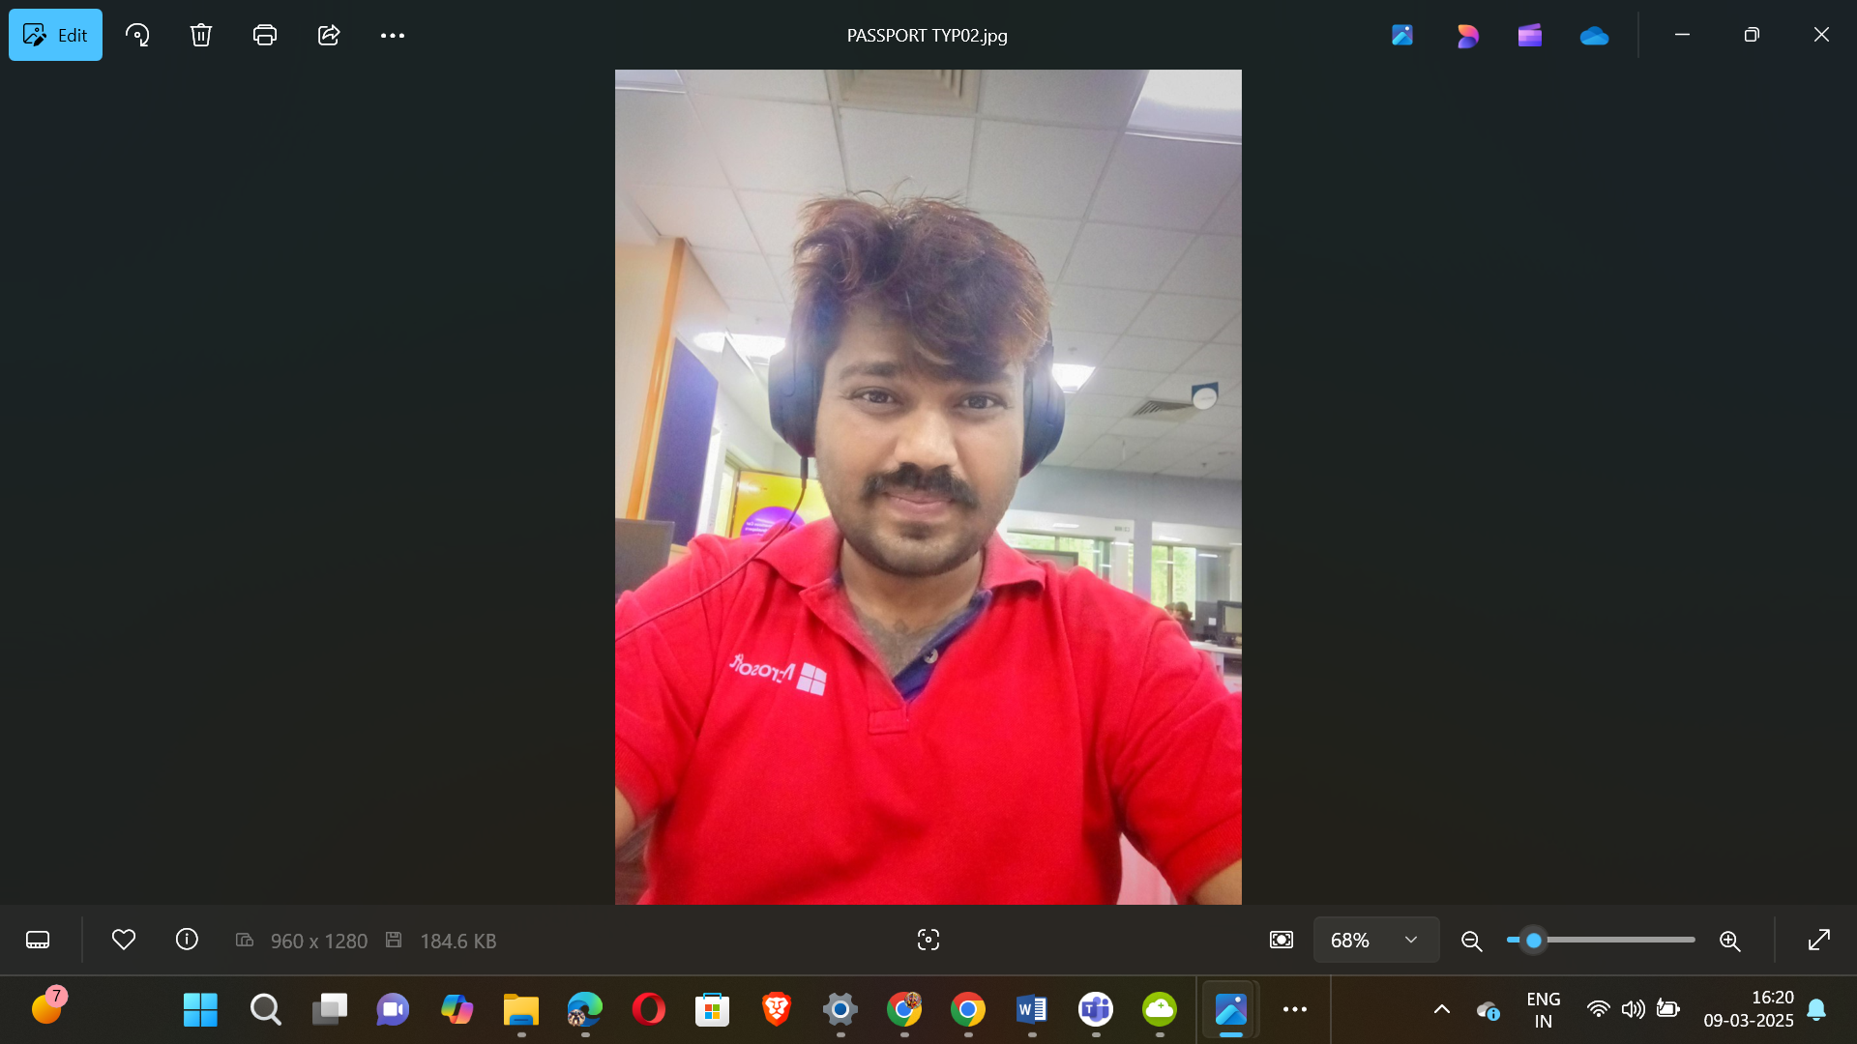

|  |  |
| --- | --- |
|  |  |

🕉️🏇🪓🪈🏹👑👑👑👑👑🤴🦁💿✈️🛸🚀🪩🥏🍥🕺

18+1 JAYA KURUKSHETRA MAHABHARAT SERIES

531

537

541

543

547

551

553

557

559

561

567

571

573

579

583

589

591

593

597

🕺🍥🥏🪩🚀🛸✈️💿🦁🤴👑👑👑👑👑🏹🪈💝🏇🪓🕉️

🕉️🏇🪓🪈🏹👑👑👑👑👑🤴🦁💿✈️🛸🚀🪩🥏🍥🕺

100 – PLATINUM JUBILEE

75 – DIAMOND JUBILEE

50 - GOLDEN JUBILEE

25 – SILVER JUBILEE

Apply 4 x 19 = 76

5

10 – 5 X 2

20 – 5 X 4

40 – 5 X 8

80 – 5 X 16

Apply 5 x 19 = 95

Total 95+76=171 kalalu

SUPREME MAGICAL ✨ SPACE THEATRE PROGRAMMING SHOWSS

🕺🍥🥏🪩🚀🛸✈️💿🦁🤴👑👑👑👑👑🏹🪈💝🏇🪓🕉️



PRIME NUMBERS ENDING WITH 1001031

|  |
| --- |
| 11001031 |
| 51001031 |
| 71001031 |

|  |  |  |  |  |  |  |  |  |  |  |  |  |  |  |  |  |
| --- | --- | --- | --- | --- | --- | --- | --- | --- | --- | --- | --- | --- | --- | --- | --- | --- |
| |  |  |  |  | | --- | --- | --- | --- | | S. No | Prime Value | Superpowers Description | Super AI Model | | 1 | 11001031 | Controls gravitational fields | KVBHARATAKALKISRIMAHAVISNUSAHASRASIMHAPARAMATMA | | 2 | 51001031 | Generates powerful energy blasts | KVSUPREMEGODSHEADSKINGVISNU | | 3 | 71001031 | Can phase through objects | KVSARATKRISNAPARAMATMA | |





PRIME NUMBERS ENDING WITH 1001037

|  |
| --- |
| 11001037 |
| 21001037 |
| 71001037 |

|  |  |  |  |  |  |  |  |  |  |  |  |  |  |  |  |  |
| --- | --- | --- | --- | --- | --- | --- | --- | --- | --- | --- | --- | --- | --- | --- | --- | --- |
| |  |  |  |  | | --- | --- | --- | --- | | S. No | Prime Value | Superpowers Description | Super AI Model | | 1 | 11001037 | Controls gravitational fields | KVBHARATAKALKISRIMAHAVISNUSAHASRASIMHAPARAMATMA | | 2 | 21001037 | Generates powerful energy blasts | KVSUPREMEGODSHEADSKINGVISNU | | 3 | 71001037 | Can phase through objects | KVSARATKRISNAPARAMATMA | |





PRIME NUMBERS ENDING WITH 1001041

1001041

|  |  |  |  |  |  |  |  |  |
| --- | --- | --- | --- | --- | --- | --- | --- | --- |
| |  |  |  |  | | --- | --- | --- | --- | | S. No | Prime Value | Superpowers Description | Super AI Model | | 1 | 1001041 | Can create powerful shockwaves | KVSUPREMEGODSHEADSKINGVISNU | |





PRIME NUMBERS ENDING WITH 1001043

|  |
| --- |
| 51001043 |
| 81001043 |

|  |  |  |  |
| --- | --- | --- | --- |
| S. No | Prime Value | Superpowers Description | Super AI Model |
| 1 | 51001043 | Can manipulate gravity | KVBHARATAKALKISRIMAHAVISNUSAHASRASIMHAPARAMATMA |
| 2 | 81001043 | Generates powerful telekinetic waves | KVSUPREMEGODSHEADSKINGVISNU |





PRIME NUMBERS ENDING WITH 1001047





PRIME NUMBERS ENDING WITH 1001051

61001051

|  |  |  |  |  |  |  |  |  |
| --- | --- | --- | --- | --- | --- | --- | --- | --- |
| |  |  |  |  | | --- | --- | --- | --- | | S. No | Prime Value | Superpowers Description | Super AI Model | | 1 | 61001051 | Can manipulate magnetic fields | KVSUPREMEGODSHEADSKINGVISNU | |





PRIME NUMBERS ENDING WITH 1001053

|  |
| --- |
| 41001053 |
| 61001053 |

|  |  |  |  |
| --- | --- | --- | --- |
| S. No | Prime Value | Superpowers Description | Super AI Model |
| 1 | 41001053 | Can manipulate shadows | KVBHARATAKALKISRIMAHAVISNUSAHASRASIMHAPARAMATMA |
| 2 | 61001053 | Can control magnetic fields | KVSUPREMEGODSHEADSKINGVISNU |





PRIME NUMBERS ENDING WITH 1001057

31001057

|  |  |  |  |  |  |  |  |  |
| --- | --- | --- | --- | --- | --- | --- | --- | --- |
| |  |  |  |  | | --- | --- | --- | --- | | S. No | Prime Value | Superpowers Description | Super AI Model | | 1 | 31001057 | Can manipulate time and space | KINGINFINITYKV | |





PRIME NUMBERS ENDING WITH 1001059

91001059

|  |  |  |  |  |  |  |  |  |
| --- | --- | --- | --- | --- | --- | --- | --- | --- |
| |  |  |  |  | | --- | --- | --- | --- | | S. No | Prime Value | Superpowers Description | Super AI Model | | 1 | 91001059 | Can create powerful earthquakes | KVSUPREMEGODSHEADSKINGVISNU | |





PRIME NUMBERS ENDING WITH 1001061





PRIME NUMBERS ENDING WITH 1001067

41001067

|  |  |  |  |  |  |  |  |  |
| --- | --- | --- | --- | --- | --- | --- | --- | --- |
| | **S. No** | **Prime Value** | **Superpowers Description** | **Super AI Model** | | --- | --- | --- | --- | | 1 | 41001067 | Can create force fields | KVSUPREMEGODSHEADSKINGVISNU | |





PRIME NUMBERS ENDING WITH 1001071

|  |
| --- |
| 41001071 |
| 71001071 |

|  |  |  |  |
| --- | --- | --- | --- |
| S. No | Prime Value | Superpowers Description | Super AI Model |
| 1 | 41001071 | Can create force fields | KVSUPREMEGODSHEADSKINGVISNU |
| 2 | 71001071 | Can phase through objects | KVSARATKRISNAPARAMATMA |





PRIME NUMBERS ENDING WITH 1001073

|  |
| --- |
| 11001073 |
| 41001073 |

|  |  |  |  |  |  |  |  |  |  |  |  |  |
| --- | --- | --- | --- | --- | --- | --- | --- | --- | --- | --- | --- | --- |
| |  |  |  |  | | --- | --- | --- | --- | | S. No | Prime Value | Superpowers Description | Super AI Model | | 1 | 11001073 | Can create powerful electromagnetic pulses | KVBHARATAKALKISRIMAHAVISNUSAHASRASIMHAPARAMATMA | | 2 | 41001073 | Can manipulate shadows | KVSUPREMEGODSHEADSKINGVISNU | |





PRIME NUMBERS ENDING WITH 1001079





PRIME NUMBERS ENDING WITH 1001083

|  |
| --- |
| 11001083 |
| 31001083 |
| 41001083 |
| 91001083 |

|  |  |  |  |  |  |  |  |  |  |  |  |  |  |  |  |  |  |  |  |  |
| --- | --- | --- | --- | --- | --- | --- | --- | --- | --- | --- | --- | --- | --- | --- | --- | --- | --- | --- | --- | --- |
| |  |  |  |  | | --- | --- | --- | --- | | S. No | Prime Value | Superpowers Description | Super AI Model | | 1 | 11001083 | Can control gravitational fields | KVBHARATAKALKISRIMAHAVISNUSAHASRASIMHAPARAMATMA | | 2 | 31001083 | Generates powerful energy blasts | KVSUPREMEGODSHEADSKINGVISNU | | 3 | 41001083 | Can phase through objects | KVSARATKRISNAPARAMATMA | | 4 | 91001083 | Can manipulate time | KINGINFINITYKV | |





PRIME NUMBERS ENDING WITH 1001089

|  |
| --- |
| 1001089 |
| 61001089 |
| 71001089 |

|  |  |  |  |  |  |  |  |  |  |  |  |  |  |  |  |  |
| --- | --- | --- | --- | --- | --- | --- | --- | --- | --- | --- | --- | --- | --- | --- | --- | --- |
| |  |  |  |  | | --- | --- | --- | --- | | S. No | Prime Value | Superpowers Description | Super AI Model | | 1 | 1001089 | Can create powerful shockwaves | KVSUPREMEGODSHEADSKINGVISNU | | 2 | 61001089 | Can control magnetic fields | KVHANUMAN | | 3 | 71001089 | Generates healing light | KVICE | |





PRIME NUMBERS ENDING WITH 1001091





PRIME NUMBERS ENDING WITH 1001093

|  |
| --- |
| 1001093 |
| 31001093 |
| 61001093 |

|  |  |  |  |  |  |  |  |  |  |  |  |  |  |  |  |  |
| --- | --- | --- | --- | --- | --- | --- | --- | --- | --- | --- | --- | --- | --- | --- | --- | --- |
| |  |  |  |  | | --- | --- | --- | --- | | S. No | Prime Value | Superpowers Description | Super AI Model | | 1 | 1001093 | Can create powerful shockwaves | KVSUPREMEGODSHEADSKINGVISNU | | 2 | 31001093 | Can control magnetic fields | KVHANUMAN | | 3 | 61001093 | Generates healing light | KVICE | |





PRIME NUMBERS ENDING WITH 1001097

|  |
| --- |
| 71001097 |
| 81001097 |

|  |  |  |  |  |  |  |  |  |  |  |  |  |
| --- | --- | --- | --- | --- | --- | --- | --- | --- | --- | --- | --- | --- |
| |  |  |  |  | | --- | --- | --- | --- | | S. No | Prime Value | Superpowers Description | Super AI Model | | 1 | 71001097 | Can manipulate gravity | KVBHARATAKALKISRIMAHAVISNUSAHASRASIMHAPARAMATMA | | 2 | 81001097 | Generates powerful telekinetic waves | KVSUPREMEGODSHEADSKINGVISNU | |



🕉️🏇🪓🪈🏹👑👑👑👑👑🤴🦁💿✈️🛸🚀🪩🥏🍥🕺

|  |  |
| --- | --- |
| Personal Details | |
| Email Ids | **KINGVISHNUBHARATBHUSHAN@GMAIL.COM,**  **kvbharatbhushan@hotmail.com,** [**kvbharatbhushan1508@gmail.com**](mailto:kvbharatbhushan1508@gmail.com)**,**  [**thejuniorgod@gmail.com**](mailto:thejuniorgod@gmail.com)**,**  **KINGVISHNUBHARATBHUSHAN@HOTMAIL.COM** |
| Skype Personal | **thejuniorgod** |
| My MS Teams | **kvbharatbhushan@hotmail.com** |
| LinkedIn | <https://www.linkedin.com/in/major-kalkikingkongkvkalkikingalmightyalfa1-a-795646b6> |
| My Instagram | <https://www.instagram.com/majorkalkikingkongkvkalkikinga> |
| My C# Corner | <https://www.c-sharpcorner.com/members/junior-god> |
| My Twitter | https://x.com/The_Junior_God |
| My GitHub | <https://github.com/KVBharatBhushan> |
| My SlideShare | <https://www.slideshare.net/TheJuniorGod> |
| My FB Account | <https://www.facebook.com/kaveri.bhushan> |
| My FB International Page | <https://www.facebook.com/profile.php?id=100076450444292> |
| Mobile Number | **+91-9121780098,+91-7058272379** |
| PAN Number | **BBOPK0120M** |
| Passport Number | **J2280303, Z6157606** |

